Database Report

Authors: Samsu Miah, Hussein Ahmed Tejan and Sanjeevan Paruthirajan

Index

The relational schema page 3 - 10

Database table commands page 11 - 14

Database test data page 15 -

Create view Commands

SQL queries

Relational Schema

* -  Some primary key: primary key
* -  (FK) keyname: foreign key
* Student (Student ID: Integer, Name: String, Degree: String)
* Exam (Exam ID: Integer, (FK) Module Number: Integer, Semester: Char, Year: Integer, Lecturer: String, Attempt: Integer, Weighting: double, Outcome: String, Marks: String, (FK) QuestionsID: Integer)
* Subject (Subject ID: Integer, Subject Name: String,)
* Module (Module Number: Integer, Module Name: String)
* Coursework (Coursework ID: Integer, (FK) Module Number: Integer, Semester: Char, Year: Integer, Lecturer: String, Mark: String, Weighting: double, Outcome: String)

Relational Schema

Staff (Staff ID: Integer, Staff Name: String, Department: String)

Grade Report ((FK) Student ID: Integer, (FK) Subject ID: Integer, (FK) Module Number: String, Module Grade: String)

Lecturer (Lecturer ID: String, Subject Name: String, Module Name: String)

Questions (QuestionsID: Integer, Marks: String)

Relational Schema

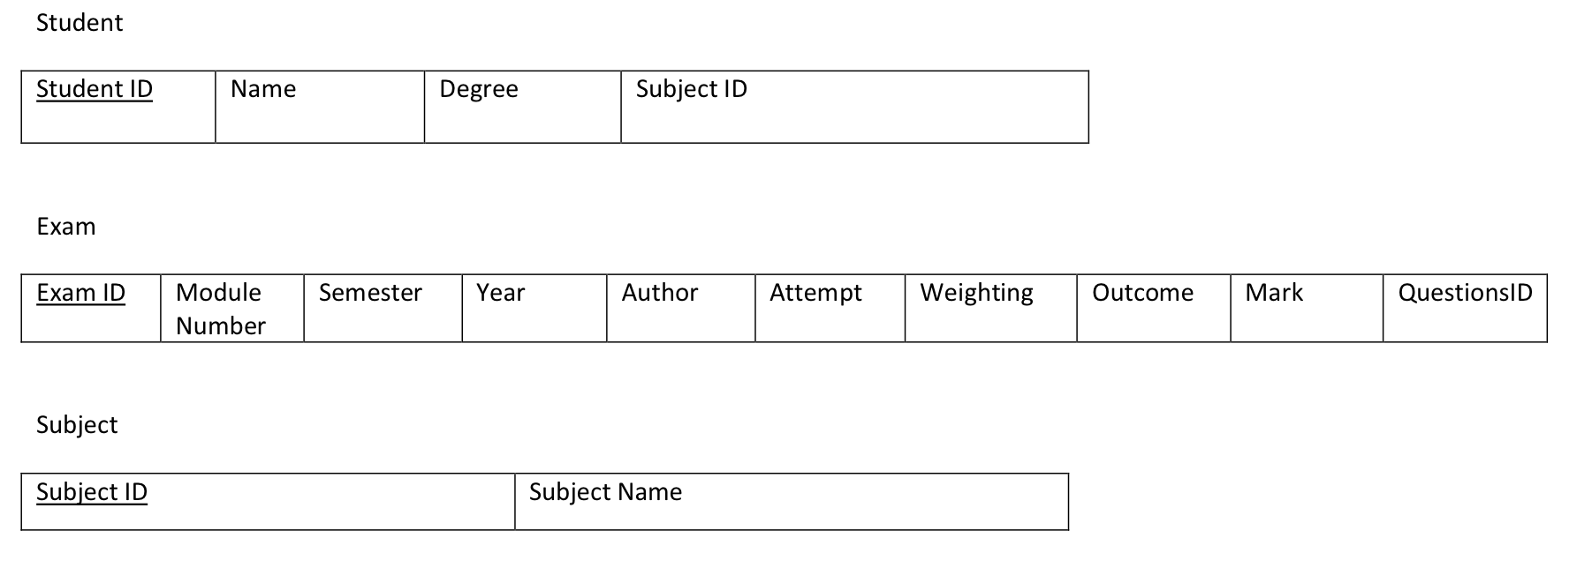

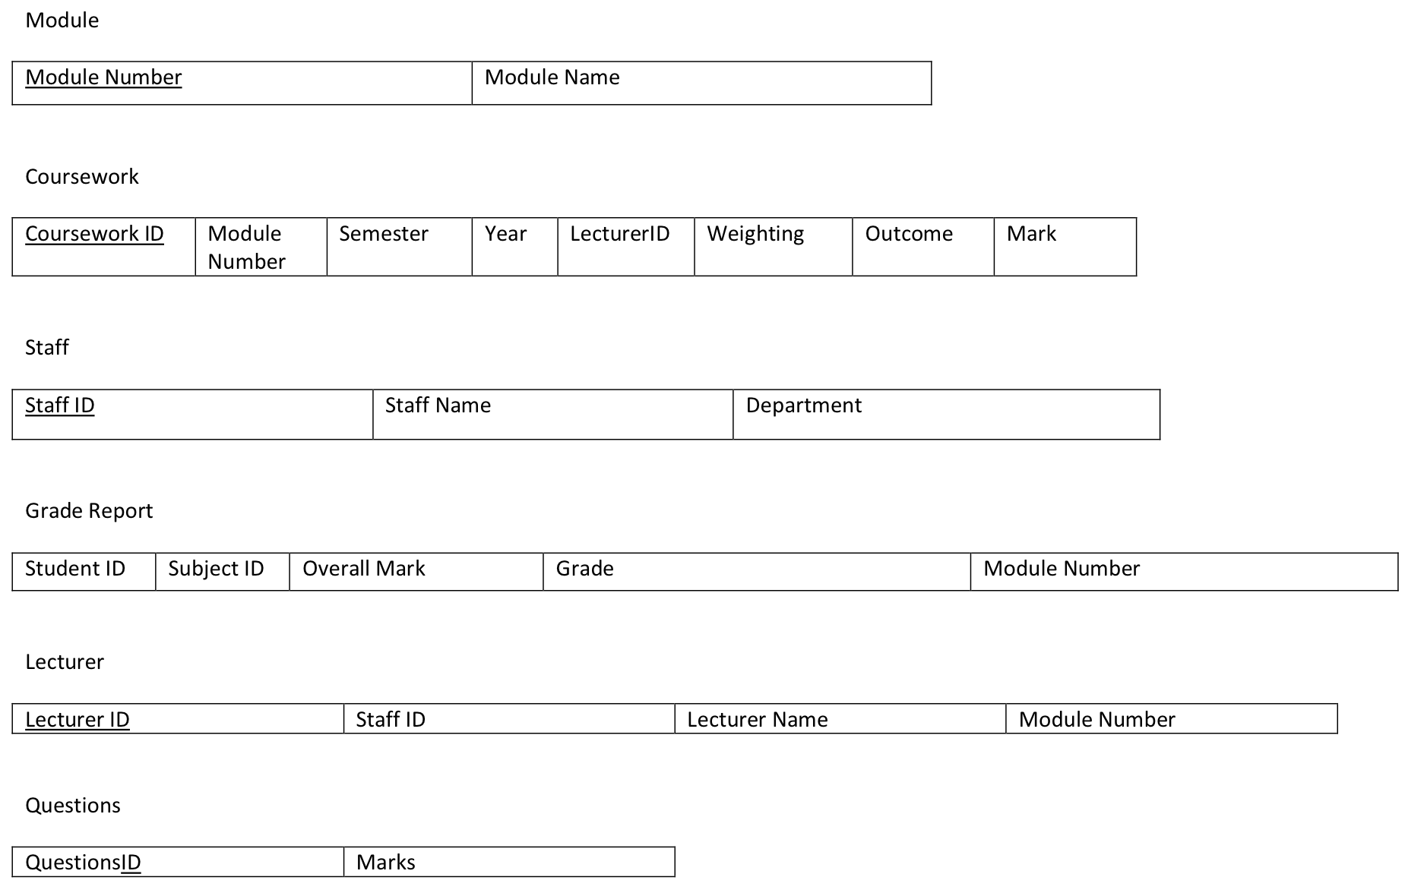

Relational Schema

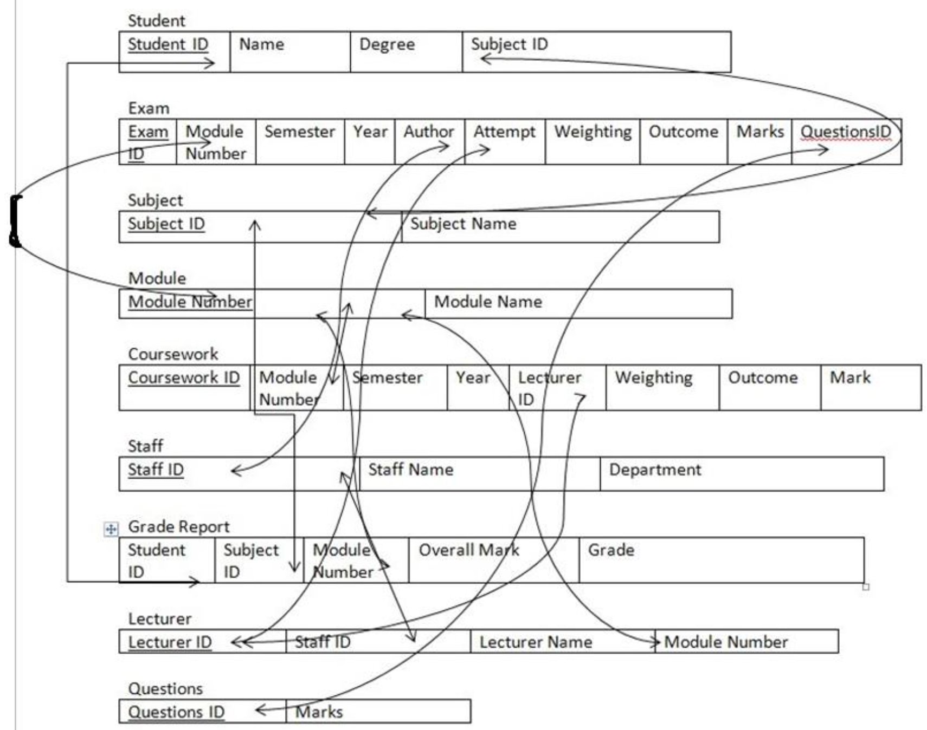

Relational Schema

Student {Student ID, Name, Degree, Subject ID} – first normal form

Exam {Exam Id, Module number, Semester, Year, Author, Attempt, Weighting, Outcome, Marks, Question ID,} – first normal form

Subject {Subject ID, Subject name}-first normal form

Module {Module number, Module name} – first normal form

Coursework {Coursework ID, Module number, Semester, Year, Lecturer ID, Weighting, Outcome, Mark}- First Normal form

Staff {Staff Id, Staff name, Department}-first normal

Grade Report {Student ID, Subject ID, Module name, Overall mark, Grade}

Lecturer {Lecturer ID, Staff Id, Lecturer Name, Module Number}

Questions {Question Id, Marks}

Second Normal Formal

Student {Student ID, Name, Degree id, Subject ID}- second normal form

Degree _class {Degree id, Degree classification}- second normal form

Exam {Exam Id, Module number, SyID, Author, Attempt, Weighting, Outcome, Marks, Question ID,} – second normal form

Sem_year {Syid, Semester, yid}- second normal form Year {yid, Year}-second normal form

Subject {Subject ID, Subject name}-second normal form

Module {Module number, Module name} – second normal form

Relational Schema

Coursework {Coursework Id, Module number, Syid, Lecturer ID, Weighting, Outcome, Mark}-Second Normal form

Staff {Staff Id, Staff name, DId}-Second normal form

Dept {Did, Department name} – second normal form

Staff {Staff Id, Staff name, Did}-first normal

Grade Report {Student ID, Subject ID, Module id, Overall mark, Grade} – second normal form

Lecturer {Lecturer ID, Staff Id, Lecturer Name, Module Number} - second normal form

Questions {Question Id, Marks}-second normal form

Student {Student ID, Name, Degree id, Subject ID}- third normal form

Degree _class {Degree id, Degree classification}- third normal form

Exam {Exam Id, Module number, SyID} – third normal form

Exam_det {Exam id, Author, Attempt, Weighting, Outcome, Marks, Question iD} – third normal form

Sem_year {Syid, Semester, yid}-third normal form Year {yid, Year}- third normal form

Subject {Subject ID, Subject name}-third normal form

Module {Module number, Module name} –third normal form

Coursework {Coursework Id, Module number, Syid, Lecturer Id}-Third Normal form

Coursework_marks {Coursework id, Weighting, Outcome, Mark}

Relational Schema

Staff {Staff Id, Staff name, DId}-Third normal form

Dept {Did, Department name} – Third normal form

Staff {Staff Id, Staff name, Did}-Third normal

Grade Report {Student ID, Subject ID} – third normal form

Sub_in_modules {Subject id, Module id, Overall mark, Grade} – third normal form

Lecturer {Lecturer ID, Lecturer Name, Module Number} -Third normal form

Questions {Question Id, Marks}-third normal form

Student {Student ID, Name, Degree id, Subject ID}- third normal form

Relation 1: Student ID, Name – Relation 2: Degree id, Subject id

Degree _class {Degree id, Degree classification}- third normal form

Exam {Exam Id, Module number, SyID} – third normal form

Exam_det {Exam id, Author, Attempt, Weighting, Outcome, Marks, Question iD} – third normal form

Sem_year {Syid, Semester, yid}-third normal form Year {yid, Year}- third normal form.

Subject {Subject ID, Subject name}-third normal form

Module {Module number, Module name} –third normal form

Coursework {Coursework Id, Module number, Syid, Lecturer Id}-Third Normal form

Coursework_marks {Coursework id, Weighting, Outcome, Mark}

Staff {Staff Id, Staff name, DId}-Third normal form Dept {Did,

Relational Schema

Department name} – Third normal form

Staff {Staff Id, Staff name, Did}-Third normal

Grade Report {Student ID, Subject ID} – third normal form

Sub_in_modules {Subject id, Module id, Overall mark, Grade} – third normal form

Lecturer {Lecturer ID, Lecturer Name, Module Number} -Third normal form

Questions {Question Id, Marks}-third normal form

Database table commands

SET TERMOUT ON

DROP TABLE GRADEREPORT;

DROP TABLE STUDENT;

DROP TABLE DEGREE_CLASS ;

DROP TABLE COURSEWORK_MARKS;

DROP TABLE COURSEWORK;

DROP TABLE LECTURER;

DROP TABLE EXAM_DET;

DROP TABLE EXAM;

DROP TABLE SUBINMOD;

DROP TABLE MODULE;

DROP TABLE SUBJECT;

DROP TABLE SEM_YEAR;

DROP TABLE YEAR;

DROP TABLE QUESTIONS;

DROP TABLE STAFF;

DROP TABLE DEPT;

SET TERMOUT ON

CREATE TABLE DEGREE_CLASS(

DEGREEID NUMBER (10) NOT NULL PRIMARY KEY,

DEGREECLASS VARCHAR (10) NOT NULL

);

CREATE TABLE MODULE(

MODNUM NUMBER (10) NOT NULL PRIMARY KEY ,

MODNAME VARCHAR (10) NOT NULL

);

CREATE TABLE SUBJECT(

SUBJECTID NUMBER (10) NOT NULL PRIMARY KEY,

SUBJECTNAME VARCHAR (500)NOT NULL

);

CREATE TABLE LECTURER(

LID NUMBER (10) NOT NULL PRIMARY KEY,

LNAME VARCHAR (10) NOT NULL,

MODNUM NUMBER(10) NOT NULL,

FOREIGN KEY (MODNUM) REFERENCES MODULE(MODNUM)

);

CREATE TABLE YEAR(

YID NUMBER (10) NOT NULL PRIMARY KEY ,

YEAR VARCHAR (10) NOT NULL

);

CREATE TABLE SEM_YEAR(

SYID NUMBER (10) NOT NULL PRIMARY KEY ,

SEMESTER VARCHAR (10) NOT NULL,

YID NUMBER (10) NOT NULL,

FOREIGN KEY (YID) REFERENCES YEAR(YID)

);

CREATE TABLE STUDENT(

STUDENTID NUMBER (10) NOT NULL PRIMARY KEY,

STUDENTNAME VARCHAR (10) NOT NULL,

DEGREEID NUMBER (10) ,

SUBJECTID NUMBER (10),

FOREIGN KEY (DEGREEID) REFERENCES DEGREE_CLASS(DEGREEID),

FOREIGN KEY (SUBJECTID) REFERENCES SUBJECT(SUBJECTID)

);

CREATE TABLE EXAM(

EXAMID NUMBER (10) NOT NULL PRIMARY KEY,

MODNUM NUMBER (10) NOT NULL,

SYID NUMBER (10) NOT NULL,

FOREIGN KEY (MODNUM) REFERENCES MODULE(MODNUM),

FOREIGN KEY (SYID) REFERENCES SEM_YEAR(SYID)

);

CREATE TABLE QUESTIONS(

QID NUMBER (10) NOT NULL PRIMARY KEY,

MARKS NUMBER(10) NOT NULL

);

CREATE TABLE EXAM_DET(

EXAMID NUMBER (10) NOT NULL,

AUTHOR VARCHAR (10) NOT NULL,

ATTEMPT NUMBER (10) NOT NULL,

WEIGHTING VARCHAR (10) NOT NULL,

OUTCOME VARCHAR (10) NOT NULL,

MARKS NUMBER (10)NOT NULL,

QID NUMBER (10) NOT NULL,

FOREIGN KEY (EXAMID) REFERENCES EXAM(EXAMID),

FOREIGN KEY (QID) REFERENCES QUESTIONS(QID)

);

CREATE TABLE COURSEWORK(

CWID NUMBER (10) NOT NULL PRIMARY KEY,

MODNUM NUMBER (10) NOT NULL,

SYID NUMBER (10) NOT NULL,

LID NUMBER (10) NOT NULL,

FOREIGN KEY (MODNUM) REFERENCES MODULE(MODNUM),

FOREIGN KEY (SYID) REFERENCES SEM_YEAR(SYID),

FOREIGN KEY (LID) REFERENCES LECTURER(LID)

);

CREATE TABLE COURSEWORK_MARKS(

CWID NUMBER (10) NOT NULL ,

WEIGHTING VARCHAR (10) NOT NULL,

YID NUMBER (10) NOT NULL,

OUTCOME VARCHAR (10) NOT NULL,

FOREIGN KEY (CWID) REFERENCES COURSEWORK(CWID),

FOREIGN KEY (YID) REFERENCES YEAR(YID)

);

CREATE TABLE DEPT(

DID NUMBER (10) NOT NULL PRIMARY KEY,

DEPTNAME VARCHAR (10) NOT NULL

);

CREATE TABLE STAFF(

STAFFID NUMBER (10) NOT NULL PRIMARY KEY,

STAFFNAME VARCHAR (10) NOT NULL,

DID NUMBER (10) NOT NULL,

FOREIGN KEY (DID) REFERENCES DEPT(DID)

);

CREATE TABLE GRADEREPORT(

STUDENTID NUMBER (10) NOT NULL,

SUBJECTID NUMBER (10) NOT NULL,

FOREIGN KEY (STUDENTID) REFERENCES STUDENT(STUDENTID),

FOREIGN KEY (SUBJECTID) REFERENCES SUBJECT(SUBJECTID)

);

CREATE TABLE SUBINMOD(

SUBJECTID NUMBER (10) NOT NULL,

MODNUM NUMBER (10) NOT NULL,

OVERALLMARK NUMBER(10) NOT NULL,

FOREIGN KEY (SUBJECTID) REFERENCES SUBJECT(SUBJECTID),

FOREIGN KEY (MODNUM) REFERENCES MODULE(MODNUM)

);

Database test data

Create view Commands

SQL queries